HORAHORA PAA
WORKING GROUP MAHI

The working group was mandated with forming the following procedures and policies. This draft document will be presented to the Horahora Paa Board of Trustees for review and approval.
Version updated: 12/06/2022

Contents
Hireage and Booking Policy: 3
Hireage Procedures Manual: 4
Horahora Paa Hireage Agreement 11
Horahora Paa COVID Policy 14
Horahora Paa COVID Health and Safety Framework: 15
Horahora Paa COVID Health and Safety Guidelines for Tangihanga and Unveiling 17
Horahora Paa COVID Protection Framework (Traffic Lights) 19
Omicron in the Community: What this means for you 20
Taupiri Maunga Urupa Guidelines 21

Hireage and Booking Policy:
- All bookings and hireage of the Horahora Paa facilities/ property will follow the Horahora Paa Hireage and Booking Procedures Manual.
- All Hirers must complete a Hirers Application form and provide all contact details.
- The Ministry of Health traffic light system, Te Puni Kokiri and Waikato Tainui COVID guidelines are adhered to for the health, safety, and wellbeing of our community:
  - Hirers contact person must be aware and adhere to the traffic light system.
  - Hirers contact person must be given the Horahora Paa Hireage Procedures Manual prior to the booking date and;
    - Be made aware of this policy and the Horahora Paa COVID-19 traffic light system
    - Hirers must comply with all the COVID procedures and posted advice.
  - The signature of the Hirer on the “Hirers Form”, will be recognized as evidence of reading and understanding, and compliance with all hireage and booking policies and procedures and especially with the COVID framework, traffic light system.
- Non-compliance may result in expulsion from the Horahora Paa premises
- All Non-compliance will be reported to the hireage coordinators and or the Board

Board Chair signature: | Joe Hatete Manukau | Date: | 12/06/2022

Hireage Procedures Manual:
Nau mai, Haere mai ki Horahora Paa.
Ka nui te mihi ki a koutou.
Ko Taupiri Te Maunga. Ko Waikato to Awa. Ko Waikato te iwi.
Ko Ngaati Pou, Ngaati Naho me Ngaati Mahuta ngaa hapuu.
Ko Tainui te Waka. Ko Horahora hanau Marae.
Ko Potatau Te Wherowhero te Tangata.
Teena Koutou, Teena ra koutou katoa.

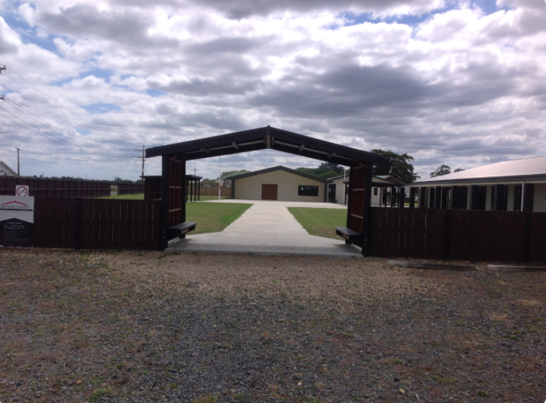

Introduction
The Trustees, Beneficiaries and Whaanau of Horahora Paa would like to take this opportunity to welcome you, your hanau or organisation to our paa. Thank you for choosing to host your special occasion/ event with us, we trust that the paa facilities are in satisfactory condition upon entry, and you enjoy your stay.

COVID-19
Horahora Paa will follow the traffic light system and the strict guidelines of the Ministry of Health and Te Puni Kōkiri, and the directives of Waikato Tainui. No Exceptions. The obligation for familiarisation of the traffic light system is with the hirer.
Please ensure that contact tracing is done every day throughout the entire stay at Horahora Paa.
The COVID-19 traffic light system and the three phases for response for Omicron is attached at the end of this document. This will influence the number of occupants who can reside in our paa.

Bookings
All bookings are to be made with the Horahora Paa Booking Officer or the Horahora Paa Treasurer:
Horahora Paa Booking Officer: | Clifford Moana 02102550659
Horahora Paa Treasurer: | Christine Moana 0221071295

Hireage Agreements
A Hireage Agreement will be sent to Whaanau/Organisations wishing to use Horahora Paa. This Hire Agreement states how the trustees would like the paa to be used while under Hireage. Note that 10am – 10am is one day hireage.
There must be two contacts named on the Hire Agreement, and one of these contacts must be present during the inspection on the day of the poowhiri and departure.

Corporate Hireage
Business and Corporate functions are subject to negotiation. Please discuss costs with the nominated trustee member. Refer to the Hireage Bond section of this manual.

Booking Deposits
A DEPOSIT will be required with Horahora Paa Booking Officer to confirm booking dates. In the event of a late cancellation there will be NO REFUND unless cancellation is advised, to the Horahora Paa Booking Officer no later than 15 working days prior to arrival date.

Hireage Bond
A BOND of $400 will be charged additional to hireage costs.
This will be reimbursed on the next business day by direct credit to the hirer once the Horahora Paa Booking Officer or other Approved Person, as directed by the Booking Officer, are satisfied that the paa is clean, tidy and checked for any breakages or damages.
Name of Account Holder: | (Refund bond to)
Bank Account Holder:

Hireage Payments

Invoices
An invoice will be sent by the Horahora Paa Booking Officer or Treasurer. Payment must be paid in full as invoiced no later than 15 working days prior to arrival date.
Horahora Paa hireage payments are to be made to:
Account Name: | Horahora Marae/Paa
Bank: | ANZ
Account Name: | 11-5736-0001463-11

Cooking Facilities
With the upgraded gas stoves and the combi pressure oven, hirers will need to undergo an induction to ensure that they are able to operate these cooking appliances correctly and safely. Once inducted, they will need operational approval to be signed off by the Approved Person. This is MANDATORY. No induction, no use.

Tangihanga
Tangihanga has precedence over any Horahora Paa Hireage Bookings.

Pae tapu, Whare tupuna, Wharekai
These are special places on the Paa. Parents and caregivers, please teach your children to respect these areas by supervising them at all times.

Horahora Paa Equipment
Paa equipment is made available for your use at time of hireage.

Hireage of Paa equipment
If hanau/ organisations wish to hire paa equipment, please contact the Horahora Paa Booking Officer.

Breakages, Loss and Damage

Paa equipment and facilities
Charges will apply to the cost of replacement or repair. Keep all breakages to determine whether wear and tear was evident.

Waste Management
All rubbish MUST be removed and sorted accordingly
Rubbish bag stickers can be purchased from the supermarkets or dairy
General waste is to be placed into black rubbish bags with the stickers on them. Please place all black rubbish bags neatly across the road just in front of Te Whare Huia.
Recycling is to be placed in the recycling bins. Food scraps to be placed in the pig scrap bins.

Laundry of Linen and Tea Towels
$85 will be charged for hireage of linen and tea towels should you need it. We encourage hanau/organisations to bring your own linen and tea towels.

Breakdowns and Faults
If Paa facilities and/or equipment breakdown or are faulty, please contact the Horahora Paa Booking Officer.

Decorations on Dining Room Walls
Strictly no decorations, posters, balloons to be adhered to any walls using Sellotape, nails, drawing pins or any other attachment that is likely to cause paint damage when removed.

Alcohol
Strictly No Alcohol is to be consumed on Horahora Paa grounds.

Te Whare Huia Clubrooms
Te Whare Huia Clubrooms are available for hire. BYO Alcohol.
Under age or intoxicated people, and public nuisances will not be tolerated and will be asked to leave the premises.
For bookings of Te Whare Huia Clubrooms, please contact the Horahora Paa Booking Officer.

He Horahora Paa Auahi Kore
Our Paa has designated smoking areas. This is the sheltered area behind the kitchen against the back fence or in the car park.

He Horahora Paa Tukino Kore
Abuse of Paa usage will not be tolerated.

He Horahora Paa Tarutaru Kore
If any illegal drugs are consumed on the paa grounds, the Hireage Agreement will cease and there will be NO REFUND.

Gang Patches and Regalia
The wearing of Gang Patches or Regalia are not permitted on the Paa

Animals
Animals are not permitted on the grounds or in the buildings.

Photos
No photos are to be removed from the Whare Tupuna. If copies are wanted, please contact the Horahora Paa Trustees.
Photos can be taken inside or outside the whare. However, please seek permission from a Trustee member.

You Must Bring
- Jif/Cream cleanser
- Steelo/Pot scrubbers
- Tablecloth or butcher roll paper
- Laundry powder
- Gas lighters
- Small bin liners
- Hand soap
- Disinfectant floors/toilets
- Hand towels
- Serviettes
- Toilet paper
- Large black rubbish bags and stickers for collection
- Containers to take all leftover kai away.

When You Leave
- Ensure the Paa and Te Whare Huia is left clean and tidy.
- Stack all the mattresses and pillows tidily in the Mattress Room.
- Vacuum carpets and remove all rubbish from the Whare Tupuna.
- Stack tables and forms tidily in the allocated places in the Wharekai.
- Leave toilets and showers clean and tidy.
- Leave all kitchen utensils and cooking equipment clean and tidy.
- Sweep and mop all floors.
- Remove all rubbish from Paa grounds and facilities.
- Further cleaning procedures are required for COVID-19 sanitation.

Horahora Paa Hireage Agreement
All sections must be completed fully.
Contact Details:
Contact Name  (The Hirer): |  | Contact Name  (Alternative):
Mobile or  Home Phone: |  | Mobile or  Home Phone:
Email Address: |  | Email Address:

Time, Date and Number of People:
Arrival Date: |  | Arrive Time:
Departure Date: |  | Departure Time:
Expected numbers for the poowhiri: |  | Expected numbers to sleep at the marae:

Other Details:
The special occasion / Event for hiring Horahora Paa?:

Have you and your hanau entered a marae previously? | Yes | No
Please tick the venue/s you would like to hire: | Te Whare I Whakaarohia  Small wharemoe  Pareue (Dining Hall and Kitchen)  Te Wharehuia (Clubrooms)
Are you bringing a Portable BBQ, or Cooking Applicance/s? | Yes and I will have it certified.  No
Linen is available upon request with an additional fee of $85 | Yes, please.  No, thank you.
Horahora Paa Booking Officer Quote: | Reference:

The Hirer’s Agreement:
I sign with an understanding that I am liable and not the Horahora Paa trustees.
I, have read the Horahora Paa Hireage Procedures Manual and I have been made aware of the posted COVID-19 procedures and agree to all of the terms.
I understand that my signature on this form is a receipt of acceptance and compliance with the above-mentioned Manual.
I furthermore agree to uphold all the responsibilities outlined in this agreement.
I understand that if we break the rules while staying at Horahora Paa, we forfeit our bond. Any damages, missing equipment/unclean premises will incur charges which will be taken out of the bond.

Confidentiality Waiver:
The Hirer is liable for the adherence to all Paa based policies especially the COVID-19 based procedures. The Hirer understands while they are occupying the Horahora Paa premises that they are liable.
The Hirer understands that their details will be held confidentially by the hiring coordinators. That this information does not obligate the Marae Board in anyway. The Information will be held in good faith. This information may be used by the Marae Board for research purposes.

Damages/Breakages:
If in the event, it is noted during post-inspection, damages, or breakages of the item/s, these will be recovered by:
- deducting from the bond, or
- if the damage is extensive, we will get quotes for repair, deduct the bond and charge the Hirer accordingly plus an administration fee for our time to collect quotes and to identify suppliers.
If no damages or breakages are incurred, a refund will be signed off by both parties.
Please note if ‘b’ is actioned, a letter will be sent to the Hirer highlighting repair and replacement costs, plus administration costs less the bond.
Horahora Paa trustees will expect payment to be made within 28 days from the date of the letter. If payment is overdue, we reserve the right to contact a debt collection agency to collect outstanding costs. To prevent this from happening, it is advisable to pay within the 28 days of the date of the letter.
We expect the Hirer to look after Horahora Paa.

The Hirer signature: |  | Date:

Horahora Paa Booking Offer / Trustee: |  | Date:

Horahora Paa COVID Policy
This policy recognises the guidelines from the World Health Organisation, Ministry of Health and Te Puni Kokiri and Waikato Tainui.
- COVID policy purpose: The wellbeing and safety of our Horahora Waikato Tainui hanau, who utilise our paa, is essential.
- Our Horahora Paa General COVID Framework is He Tikanga Pai (COVID) o Horahora Paa:
- Whaanau who are mauiui or have a cold, flu, or COVID-19 symptoms, are encouraged to stay home and call a doctor, iwi health provider, or call Healthline for free on 0800 358 5453 and to get tested for COVID.
- We encourage that hanau who have tested positive for COVID-19, or are awaiting results, to remain at home until they receive a negative result.
- Ministry of Health traffic light directives are to be followed, especially with regards to the attendance protocols.
- Our Health Plan and other measures will be displayed and communicated to all attendees.
- Local Hauora or Māori health provider contact details will be displayed throughout the paa.
- The World Health Organization advises that friends and hanau may view the body after preparation for burial but are encouraged not to kiss or touch the body.
- Contact Tracing: We encourage the person who organised the gathering to take a guest list to help with contact tracing. The best way to keep contact tracing records is by whanau scanning the NZ COVID Tracer QR code.
- The NZ COVID Tracer QR code poster is to be posted throughout the paa. Whaanau are to be encouraged to scan in.
- COVID Signage: Only current official Ministry of Health signage is to be posted throughout the paa.

Board Chair signature: | Joe Hatete Manukau | Date: | 12/06/2022

Horahora Paa COVID Health and Safety Framework:

Marae attendance and protocol during Te Pae Mataara COVID
This framework recognises Ministry of Health Traffic light system, and Te Puni Kokiri and Waikato Tainui guidelines.
We encourage that when utilising the paa that our safety is paramount and maintained by following our Traffic Light system and following the policies set out by the Horahora Paa Board of Trustees.

Wharenui
The Wharenui must be deep cleaned prior to, and after occupation. This includes spraying and wiping all the surfaces with sanitising spray utilising disposable cloths. Special attention is to be given to tables, door handles, light switches including communal and frequently touched areas including the carvings.
Safe physical distancing is to be adhered too. If people cannot maintain physical distances, masks must be used.

Whare paku/Whare horoi
The whare paku/whare horoi, must be deep cleaned prior to, during, and after occupation. This includes spraying and wiping all surfaces with sanitising.
Spray utilising disposable cloths. Special attention is to be given to the wash basins, shower cubicles, tables, chairs and door handles and light switches. Handwashing/sanitising facilities are to be available.
Safe physical distancing is to be adhered too. If people cannot maintain physical distances, masks must be used.

Wharekai
Separate entrance and exit to and from wharekai will be clearly sign posted.
All surfaces are to be cleaned prior to and throughout the occupation of the Marae. A deep clean of all surfaces. Sanitising spray and disposable cloths are to be used. Special attention is to be given to the sinks, tables, chairs, door handles and light switches. Utensils, plates, cups, pots and serving equipment are to be washed, steam cleaned and dried prior to and following service.
Whanau serving food and drinks must wear a face coverings. Handwashing/ sanitising facilities are to be available.
Safe physical distancing is to be adhered to. Where people cannot maintain physical distance masks must be used.
Safe serving adherence is to be followed in line with Ministry of Health guidelines.

Waharoa
All surfaces are to be cleaned prior to and throughout the occupation of the paa. Sanitising spray and disposable cloths are to be used. Handwashing/ sanitising facilities are to be available, and use, encouraged.
Safe physical distancing is to be adhered too. If people cannot maintain physical distances, masks must be used.

Paepae
All surfaces are to be cleaned prior to and throughout the occupation of the paa. A deep clean of all surfaces after occupation. Sanitising spray and disposable cloths are to be used. Handwashing/ sanitising facilities are to be available. Communal areas and frequently touched surfaces such as paepae chairs are to be cleaned following and during the occupation. PPE face masks and gloves are to be worn during the occupation of the paa.
Safe physical distancing is to be adhered to. Where people cannot maintain physical distance masks must be used.
If you have any questions or concerns, please speak with a member of the Horahora Paa Board of Trustees.

Horahora Paa COVID Health and Safety Guidelines for Tangihanga and Unveiling
- Contact Tracing:
Whaanau Pani/Whaanau/Manuwhiri are asked to scan in using the QR code displayed at the Waharoa. A manual sign in register for those who don’t have the app will be provided. The register must be held by the booking person for at least a month and disposed appropriately. The register may be required by the Ministry of Health for contact tracing purposes if there is an outbreak of COVID-19, delta or omicron. There are QR codes in and around the paa.
- Sanitisers will be provided throughout the paa.
- Masks to be worn appropriately. Masks will be provided for whaanau that need them.
- Protect our Whakapapa:
If you are sick, symptomatic or unwell. Please stay home
- Whakaeke Times:
Under the traffic light restrictions whanau need to manage numbers attending tangihanga. Previous tangihanga have been managed well using Facebook, utilising separate time slots for vaccinated and non-vaccinated whanau.
- Paepae: It is recommended there be no hongi hariru or kihi following mihi. Once the mihi is completed, whaanau pani kaumatua will advise of kai process.
- Poomihi / Karakia: Whanau must be at least one mitre apart and masks worn indoors and outdoors. Signage will be available for vaccinated and non-vaccinated areas. It is recommended COVID-19 safety restrictions be followed.
- Taupiri Maunga: Guidelines and contact numbers are included for all burial, cremation, unveilings
- Wharekai and Kitchen Areas: All kaimahi are encouraged to scan in using QR codes displayed at entrances to kitchen and dining areas including a manual sign in register for those who don’t have the app. Kaimahi in dining areas are encouraged to wear masks and gloves where appropriate.
All kaimahi are advised to follow hygiene procedures. Signage is posted in your working areas as a reminder.
Cleaning procedures must be followed during and at the end of day as per Horahora Paa Health and Safety Framework.
A first aid kit is available for your use in case of injury is located in the back-room kitchen area.
- Coordinator’s List (suggestion only):
Kai Karanga:
QR Codes/Register:
Waharoa:
Paepae:
Kitchen:
Dining:
Toilet/Showers:

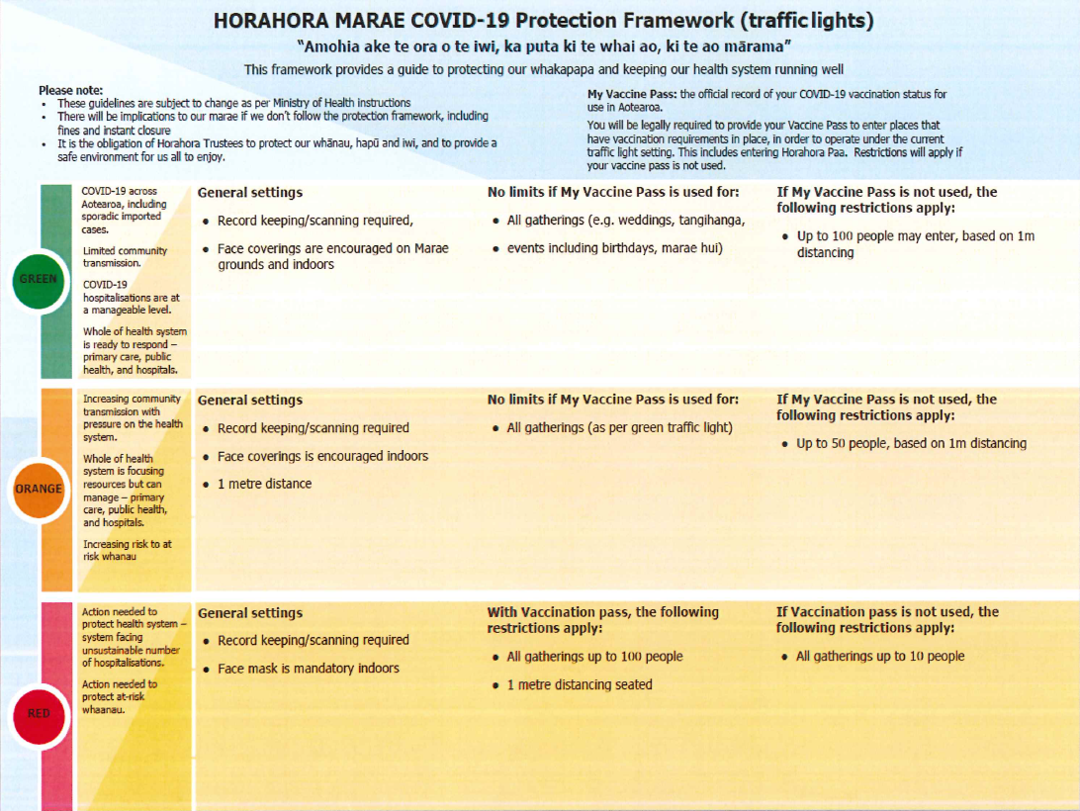
Horahora Paa COVID Protection Framework (Traffic Lights)
DRAFT

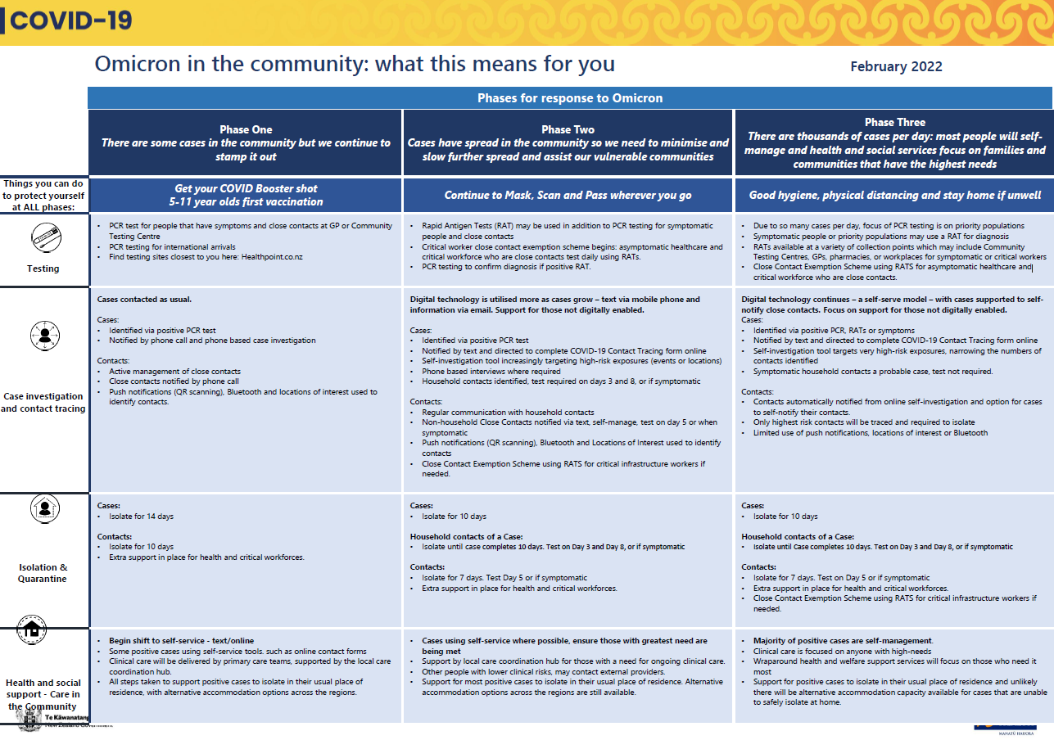
Omicron in the Community: What this means for you


Taupiri Maunga Urupa Guidelines

